1. 
2. 
3. Two ways to handle collision
   1. **Chaining**: Store address of the linked list in array instead of storing value itself.
   2. **Open Address**: Find a different slot for storing the second value.
      1. There are many open addressing algorithms.
4. 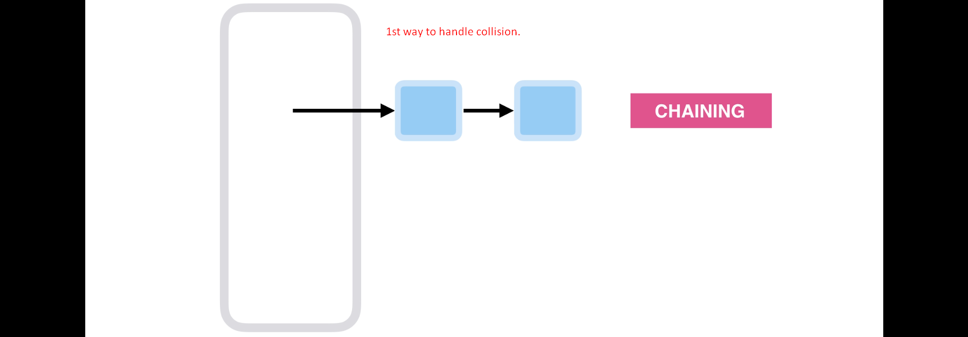
5. 